2019
DenizBank A.Ş.

Card Payment Systems DenizBank Virtual POS® - VPOS®

DenizBank Virtual POS® Application User Guide
Distribution: October, 2015 VP. V.15.06.15
To use DenizBank VPOS Back Office application, please visit: https://spos.denizbank.com

Contents
- What’s Virtual POS (VPOS)? 3
- How Does Virtual POS work? 3
- User Identification and Authority Management Displays 3

  - Login Display 3
  - Password and user information update 4
  - Display authority profile edit 4
  - Merchant identification 6
  - Terminal adding and editing 6
  - User editing and authorization 7
- Provision-Authorization and Report Displays 11
  - Login Display 11
  - Main Display 11
  - Manual Provision 12
  - Provision Cancellation 12
  - Return of Provision 13
  - Transaction Inquiry 13
  - Pre-provision Closing 14
- Reports 14
5.1. Transaction Monitoring Report 14
5.2. Order Reports 15
5.3. Batch Query 15
- Additional Information 16

1. What is Virtual POS (VPOS)?
VPOS (Virtual Point of Sale) is the adaptation of the POS (Point of Sale) devices, used for the shopping via credit cards, to electronic commerce carried out over the internet. Thanks to this system, shopping between the shops and customers can be realized over the internet in an electronic environment as a real time (on-line) process. These transactions/payments made by the customers,are paid into the firm’s account in the bank with which the merchant have made an agreement to get Virtual POS service.

The firms’ integration into the Virtual POS system over their website is a quite easy process. It will suffice for the firm to add software parts or links, given by the Bank, to its existing system, after signing the merchant and e-commerce agreements with the bank where the firm’s business account has been opened.

2. How Does Virtual POS Work?
The customer’s card details, who wants to make payments by a Credt Card, on any electronic shop, are transmitted to the Bank system which provides the Virtual POS system, through the shop system via a secure protocol (*). The Bank manages the flow (authorization) of certain controls performed about the Card and the Merchant, within its own system. This process results in giving approval or rejection feedback to the customer, over the shop system.

(*)During the course of Virtual POS flow, all transactions are carried out digitally between the two points (the Bank-the Merchant). After the control carried out between the bank and the merchant via a digital certificate, the received approval information, returns from the bank to the merchant’s payment system as a authorization (converting into cash). As a result of such flow, the shopping amount is deducted from the customer’s credit card who carried out the transaction and is transfered into the merchant’s bank account (within the scope of agreement made with the bank, and according to the relevant specified conditions). The Merchant can do all necessary transactions such as settlement (return/cancellation), monitoring turnover information and manual end of day etc, over the VPOS displays provided by the Bank, This document includes detailed explanations on application use.

3. User Identification and Authority Management Displays

3.1. Login Display

After identification of Shop (Merchant) and VirtualPos (Terminal), by means of the Merchant from “shop admin user” information which is required for management of authorities and identification of users, the Merchant code and user name e-mail shall be assigned and password shall be sent by Denizbank via SMS. It is possible to enter the management display from “https://spos.denizbank.com” URL.

Merchant admin user is able to see application menu by entering given information into “User Code” and “Password” fields from “Login” display. In case of need for “English” or “Russian” usage of the application, from “Language” tab desired option must be selected.
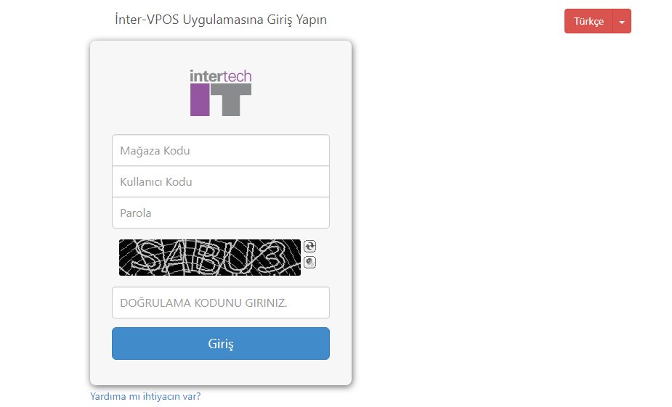

3.2. Password and user information update

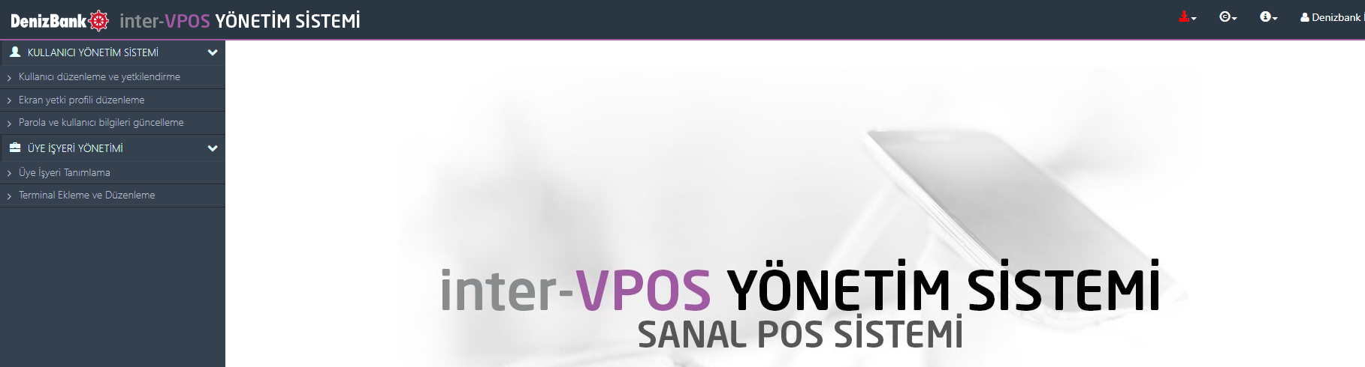

Merchant admin user, after “Login”, primarily must change a password given by the Bank on “User information and password change” display, new password must contain lower and uppercases (small and capital letters) and numbers (new password must contain at least 8 characters and numbers to be chosen from A to Z, 0 to 9, lower and uppercase, without Turkish characters). By assigned new password, re-entry must be done.

From the same page it is possible to change or edit user information such as Name, Second Name, Telephone number and E-mail address etc.

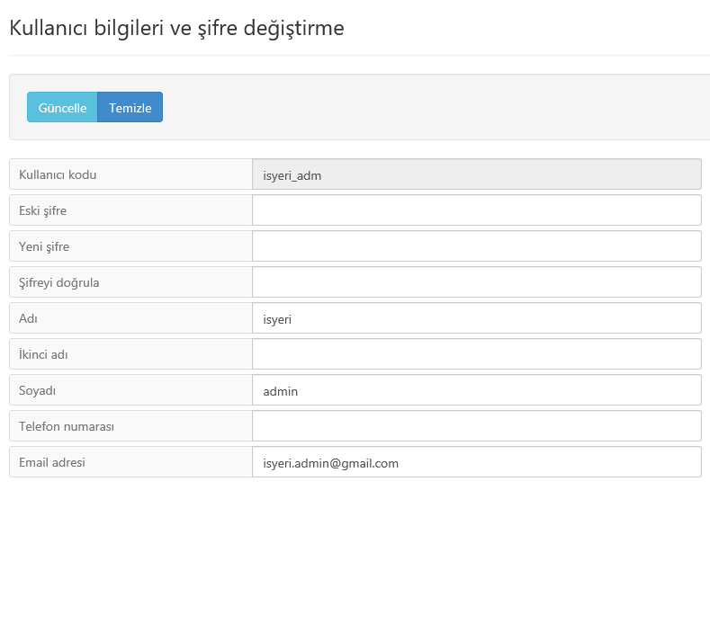

3.3. Display authorization profile edit

Merchant admin user can make edit on all of its display authorities given by the bank and create new authority grups for desired users to be identified. The Merchant by making restriction on authorities identified for itself, at the same time shall restrict authorities of users to be assigned as it is needed. By means of using the same display, the Merchant is able to make change on previously identified “Authority Group”.

If it is desired to make editing on present definitions, respectively by using “Update”, later from “Display Authority Group List” selecting present profile and “Bring-Display” tab, the profile must be displayed.

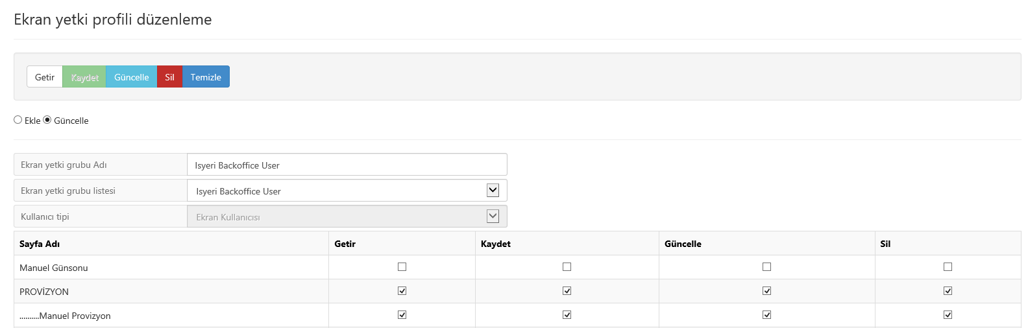

From authority profile list exist on the same page, by checking lower boxes of Getir (Bring-Display), Kaydet (Save-do transaction), Güncelle (Update-change on present registration) and Sil (Delete-deactivate parameter or transaction registration) authorities from “Sayfa Adı-Page Name” become active and by unchecking the said boxes they become passive. After completion of all changes, by using “Güncelle-Update” button on the upper part of the display, such changes will be saved.

For assigning of a new display profile, with the difference of the said flow “Ekle” (Add) must be chosen, “Ekran yetki grubu Adı” (Display Authorization Grup’s Name) and for saving of definitions the upper “Kaydet” (Save) button must be pressed.

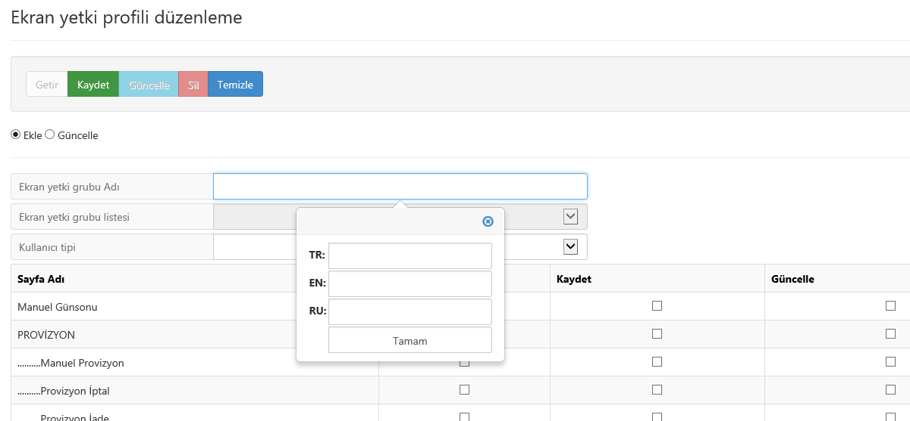

Notes:

- If it is desired to create a new profile, (Ekle) the field of “Ekran yetki grubu Adı” (Name of display authorization group) shall be displayed as active and “Ekran yetki grubu listesi” (List of display authorization group) shall be passive. After completion of the transaction, if it is needed to make change on the profile (Güncelle – Update), this new profile shall be indicated on the list of “Ekran yetki grubu listesi”.

- When “Ekran yetki grubu Adı” is chosen, it is possible to login in different TR, EN and RU language options exist on the opened window.

3.4. Merchant Identification (admin monitoring display)

This display is used by Merchant admin user for displaying of the firm information registered in the Bank’s system. In case of request to make any change on such information, related request must be sent via the branch to VirtualPOS Operation unit.

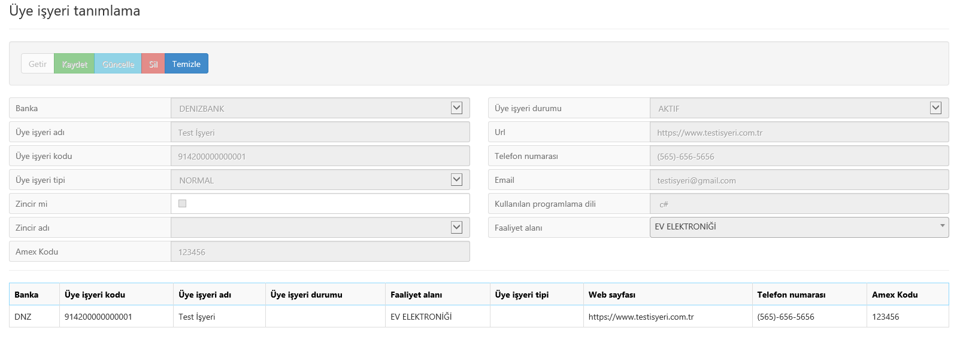

3.5. Terminal Adding and Editing (admin monitoring display)
Bank: It is displaying field for bank of the firm which is identified in the system.

Merchant’s Name is displaying field for name of the firm which is registered in the bank’s system.

Terminal Code is the firm’s terminal number which is identified in the bank’s system.

Shop Code is a unique digital value to be used by the firm on online transactions or backoffice login display.

Terminal Status indicates active/passive status of the Merchant. If the firm requests, in case of need “Geçici Kapalı” (Temporary Closed) status can be assigned.

Terminal Transaction Authorities are transaction authority combination group (TYG-Terminal Yetki Grubu) assigned based on request of the firm.

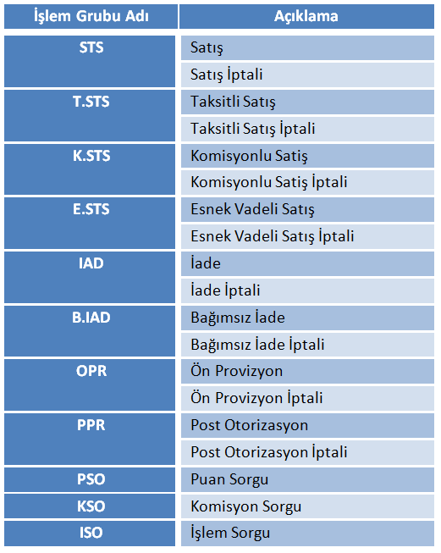

Notes : Merchant admin user’s authorities are restricted by “Terminal işlem yetkileri” (Terminal transaction authorities). Values indicated in this field must be taken as reference for authority assigning to be done on “Kullanıcı düzenleme ve yetkilendirme” (User edit and authorization) display.

Security Type: E-commerce security methods under the Firm’s authority are listed (3DPay, 3DHost, 3DModel, NonSecure, Moto).

Batch Number: It is a digital value which provides grouping transaction in defined periods and pursuit them. If Merchant does not make another choice, batch number shall be increased every day. In case no financial transaction realized within the same day, batch number will not be changed.

Multiple Currency: If terminal supports other currencies, this box must be checked. In case the box is unchecked this means that except TL other currencies are not supported in that case.

Closing Date: It means closing date of terminal by the Bank.

3D Hash Component: When a Merchant sends a sale request to the bank via 3D methods, it sends calculated password information together with the said request. During calculation of that password, 3D hash component is added to the calculation also. The bank verifies related merchant by means of this calculation..

Batch profile name: It is a profile list which is set (Daily-23:59:59) based on the merchant’s prefer or on standard method.

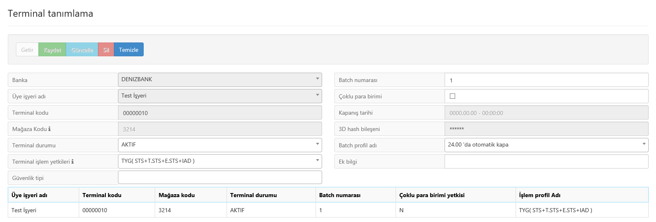

3.6. User edit and authorization

It is the display on which admin user defines online and backoffice users. Admin user must create online user for transactions to be implemented on related merchant’s virtual shop and must definitely create backoffice display user for operational transactions to be done by itself.

Bank: It is displaying field for bank of the firm which is identified in the system.

Merchant’s Name: It is displaying field for name of the firm which is identified in the bank’s system.

Terminal Code: It is the firm’s terminal number which is identified in the bank’s system. If the Merchant has more than one terminal, in this field all of them must be listed. Each identified user is solely authorized on terminal identified for itself. One user can not be identified for more then one terminal.

User Name: It is name information of user identified on related terminal.

User Type:

Online: It is “usercode” information during sending of 3D transactions done on virtual shop of the Merchant to the Bank.

Display Users: They are the merchant’s users who can be entered on “https://www.spos.denizbank.com.tr” address to VirtualPOS backoffice displays.

User Status: It is the field on which status of new user to be created or updated is selected.

Active: It is the status assigned on Virtual POS system for users who are able to do transactions within the framework of their defined authorities.

New Identified (Changeable Password): It is a status identified by the merchant’s admin user for the user who has not changed its password as login for the application yet.

Closed: It is a status assigned for users temporarily or permanently blocked for use.

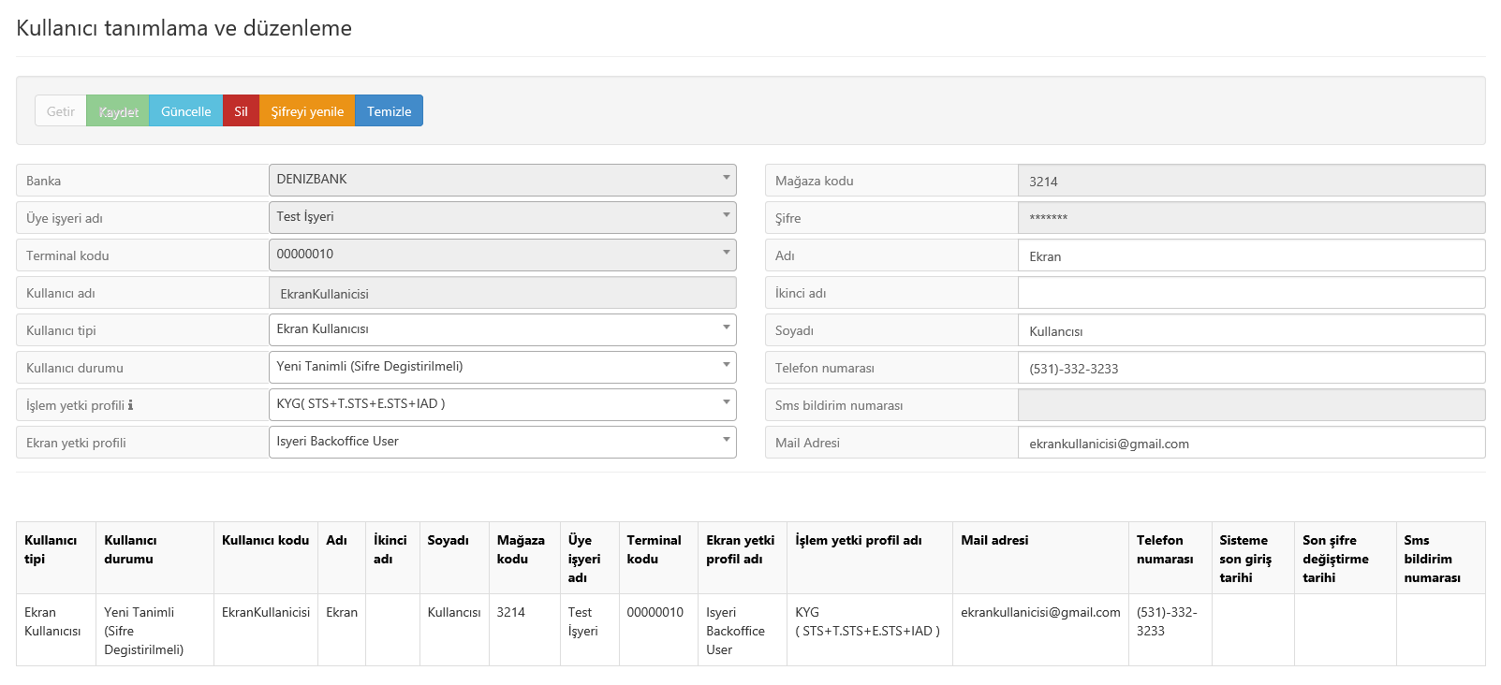

Blocked (Wrong Password): It is the status assigned by the system in case a user enters its password wrong in three times.

Blocked (If not entered for long time): It is a status automatically assigned by the system if a user does not make any transaction for 90 days.

If a standard user request from the manager (Admin) that its admin password is blocked and it must be unblocked, then Admin by using “Getir” (Bring-Display) button, primarily shall provide listing of Merchant’s display users. Admin shall select password blocked user by Mouse and by means of Mouse selecting the said user’s info shall be visible on upper fields. If Admin selects “Active” from the list in “Status” field and presses “Update-Güncelle” button, related blocking shall be undone.

If display user forgets its password requests from the merchant’s manager (admin) to create a new password. The manager primarily shall select this user from related list exists at bottom of the screen and display its information. Then by means of “Renew Password” the admin shall create new password. The Admin shall read the value generated by the system from “Password” field and note down. In this case the Admin must be sure that “User Status” on the list exists at bottom of the screen is indicated as “New Identified (Password Changed)”. When password of the user is changed, this status info shall be updated by the system as “Active”.

Another matter that must be taken into consideration by the Admin is to provide correctly and securely forwarding the value generated in “Password” field. The Admin must not forget that all responsibility and initiative has been taken by itself.

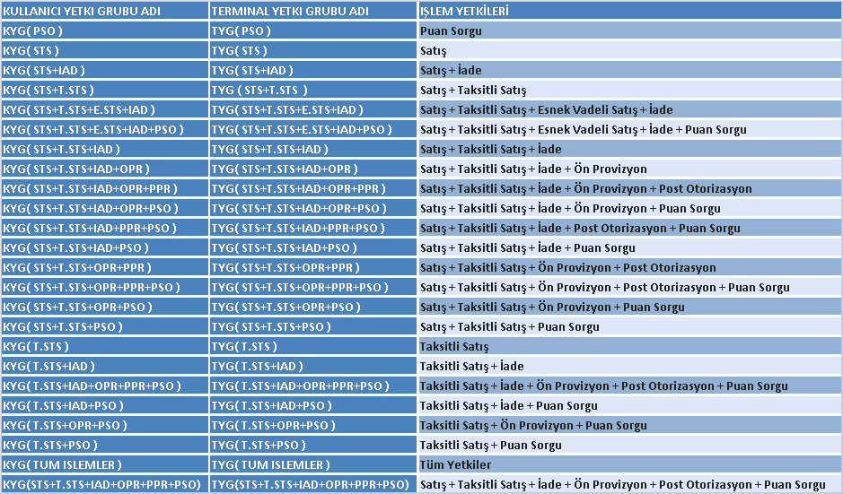

Notes : STS (Sale) - T.STS (Installment Selling) - K.STS (Commission Sale) - E.STS (Flexible Dated Sale) - IAD (Return) - B.IAD (Discrete Return) - OPR (Preauthorization/Pre-Provision) - PPR (Post Authorization) transaction authorities contain cancellation powers at the same time.

Shop Code: It is identity information of the firm to be used online transactions or backoffice login screens. It is created as unique for each terminal. It can not be changed by the Merchant.

Password: It is a field on which a value generated by the system when password information must be indicated in new user definitions or renewed. Except of the these two cases password information of users are indicated as masked in this field. In case a new password generated for present online user, firms must definitely update password value exists in their software development media, otherwise it should not be forgotten that transactions will fail.

Name: It is a field in which name information of newly created or upgraded users are entered.

Second Name: It is a field in which 2nd name information of newly created or upgraded users are entered.

Surname: It is a field in which surname information of newly created or upgraded users are entered.

Telephne Number: It is a field in which telephone numbers of newly created or upgraded users are entered.

SMS Notification Number: It is used just by admin users. By means of telephone number indicated in this field Merchant admin user is notified about password and other notifications.

E-Mail Address: It is a field in which e-mail address information of newly created or upgraded users are entered.

4. Authorization and Report Displays

4.1. Login Display

As indicated above, after display user definitions, by means of Shop Code, User Code and Password Information on the same website address (URL), login to the application is implemented.

4.2. Main Display

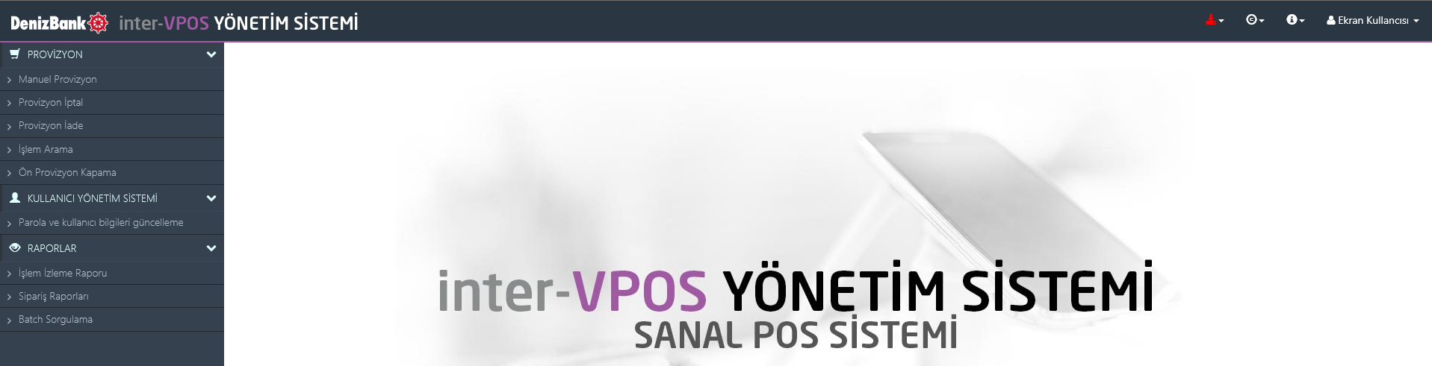

Merchant admin user, after “Login”, primarily must change a password given by the admin on “User information and password change” display, new password must contain lower and uppercases (small and capital letters) and numbers (new password must contain at least 8 characters and numbers to be chosen from A to Z, 0 to 9, lower and uppercase, without Turkish characters). By assigned new password, re-entry must be done.

From the same page it is possible to change or update user information such as Name, Second Name, Telephone number and E-mail address etc.

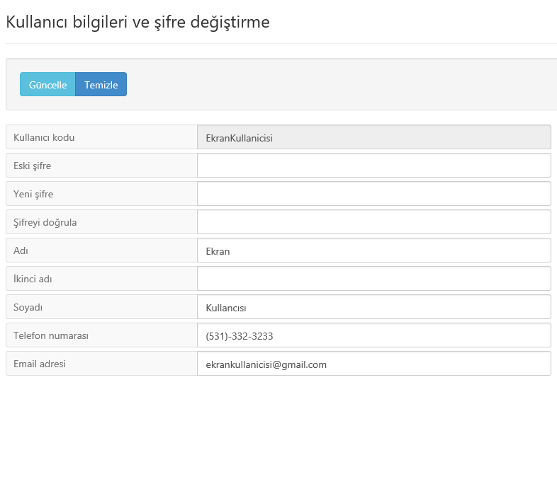

4.3. Manual Provision

It is a display that the merchant can do moto selling (manual order) within framework of terminal or user authorities. Based on chosen transaction type, places to be filled are indicated in white color.
Order number field can be remained blank (if value is not entered it shall be generated by the system) otherwise the firm must enter one single use value per each transaction. In order to follow records very easily from reports related on transactions, information can be entered in explanation field.

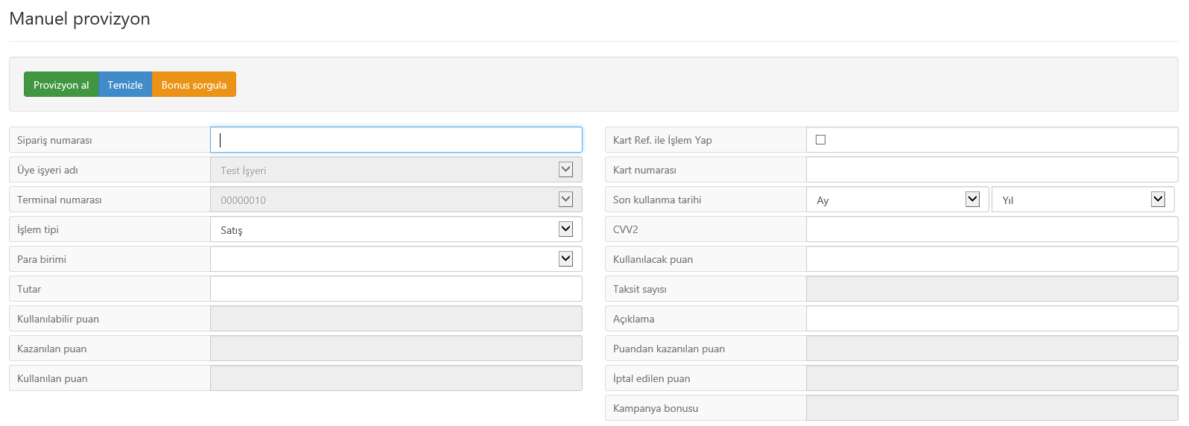

Bonus Inquiry: From the same display, customer’s card information (card no, expiry date, cvv) can be inquired. In the light of these info, sale transaction may be implemented by means of total of selling or bonus payment determined by the customer (Fields of Amount and Points to be Used must be taken into consideration when amounts are entered).

Installment Selling: For implementation of installment selling transaction, Bonus Terminal and customer card must be a bank card which is a member of Denizbank or a Bonus member bank card.

4.4. Provision Cancellation

Cancellation must be done on the same day of selling. In case of Date or Batch Number changes, cancellation transaction can not be done. A transaction to be cancelled can be listed by means of “Bring-Display” button via entering fields of Card Number, Order Number or Transaction Reference Number. If such information are not recorded in any place, in workplaces having lot of transactions, related transaction list can be shortened by means of “Transaction Type” and “Installment Numbers” criteria. Cancellation transaction is implemented by pressing “Cancellation” button after selecting related transaction from the list.

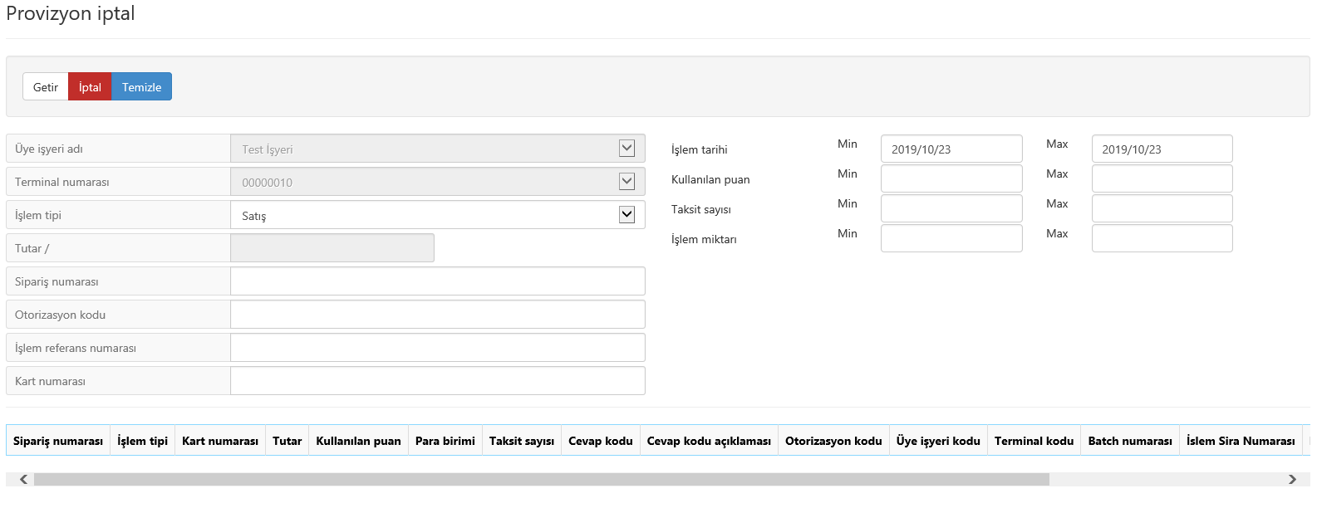

4.5. Return of Provision

Return transaction can be done on the same day of sale. A transaction to be returned can be listed by means of “Bring-Display” button via entering fields of Card Number, Order Number or Transaction Reference Number. If such information are not recorded in any place, in workplaces having lot of transactions, related transaction list can be shortened by means of “Transaction Date”, “Transaction Type” and “Installment Numbers” criteria. Return transaction can be implemented partially, if a part of selling transaction paid from bonus point, the amount to be returned shall be primarily closed from the bonus point.

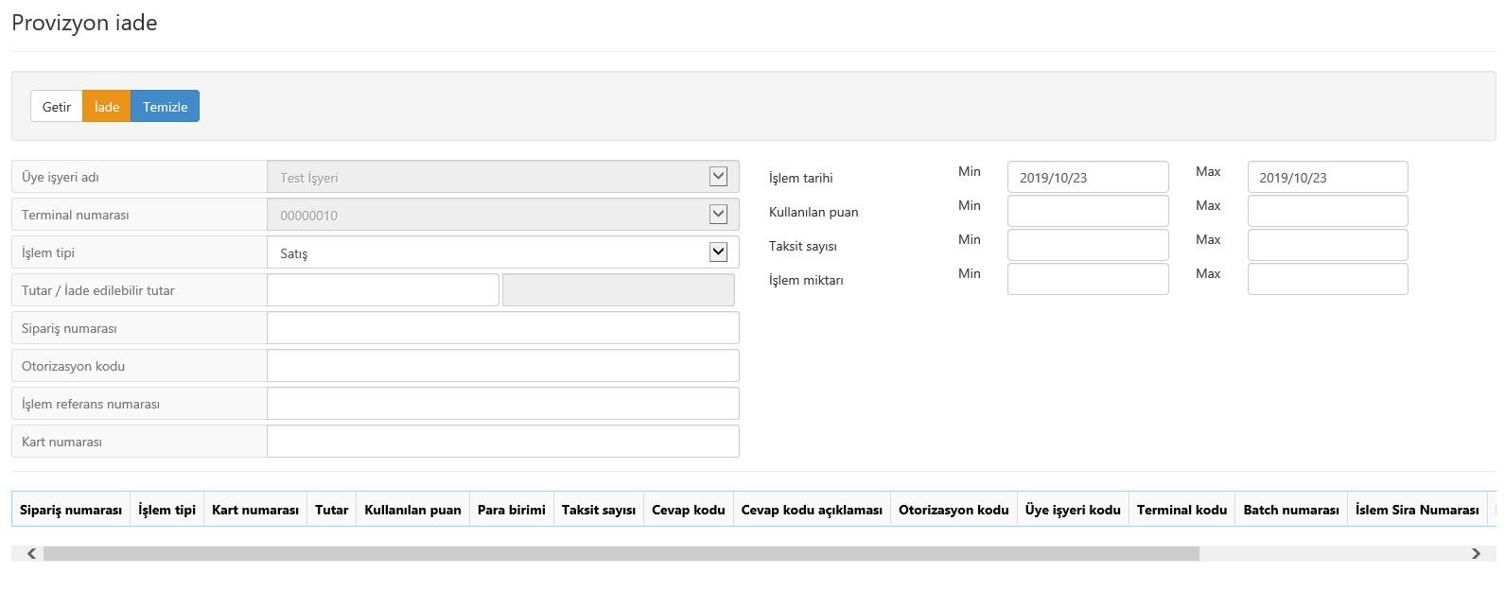

4.6. Transaction Inquiry

All transactions implemented on VirtualPOS system and detail information can be investigated by searching on this display. Basic searching criteria are “Card Number”, “Order Number” or “Transaction Reference Number”. In order to find another transaction record except from these info, we must add other criteria such as “Transaction Date” (max.-min), “Transaction Amount” (max.-min) etc. into our inquiry. Again if we have too many record in the found list and it takes time to find our searced transaction, adding “Transaction Source” (Online/BackOffice) and “Transaction Status” shall make smaller our transaction cluster. Unless a contrary profile specified, “Batch Number” shall list transactions for a single day, it can be used by taking this matter into consideration.

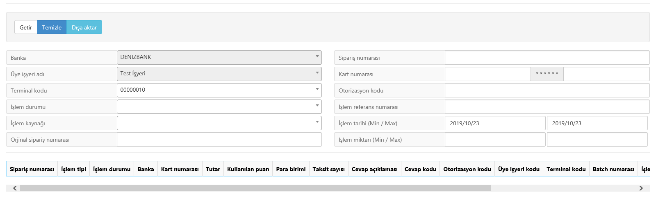

4.7. Preauthorization/Pre-Provision Closing

By means of preauthorization transaction, it is provided to block out card limit up to the amount of selling for a period of 23 days. During this time, if preauthorization closing or return transaction has not been done, the amount of blocking shall be automatically taken by the system. In case of preauthorization closing, transaction amount can be flexed at max. + 15% margin. For closing transactions below the said amount, a negative margin is not applied.

Preauthorization transaction record before closing can be found by means of “Bring-Display” button via entering fields of “Card Number”, “Order Number” or “Transaction Reference Number”. If such information are not recorded in any place, in workplaces having a lot of transactions, related transaction list can be found by means of “Transaction Date” interval, “Transaction Type” and “Installment Numbers” criteria.

When a transaction selected from the list, detailed information sent to upper fields at top of the screen. If amount of closing transaction is needed as emphasized before, by changing of “Amount” field and pressing the button of “Preauthorization Closing”, blocking of card limit shall be turned into selling transaction.

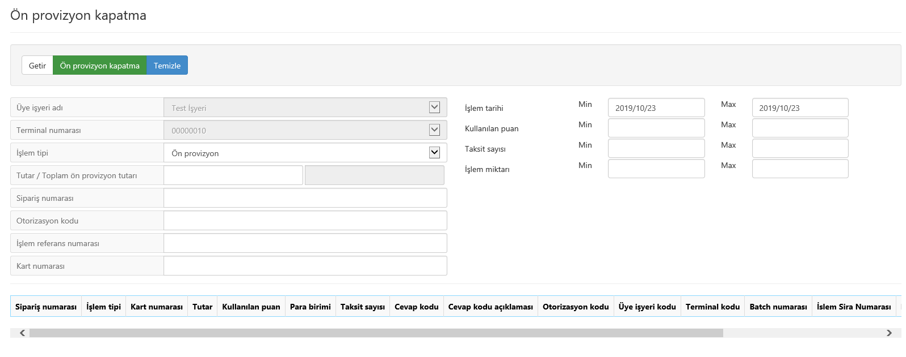

5. Reports

5.1. Transaction Monitoring Report

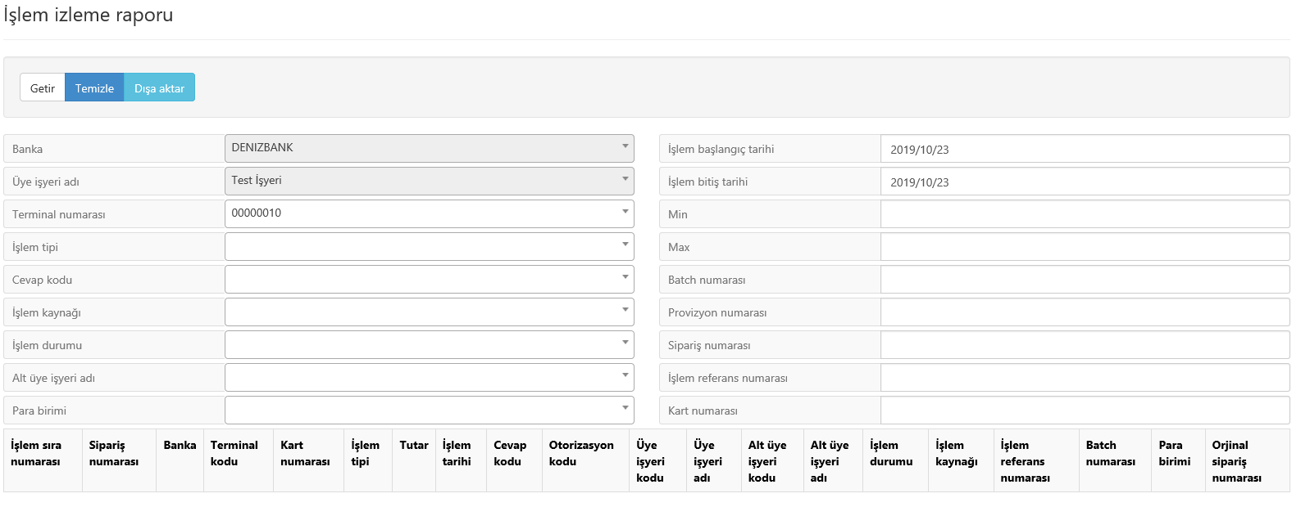
Basic searching criteria in this display are “Card Number”, “Order Number” or “Transaction Reference Number”. In order to find another transaction record except from these info, we must add other criteria such as “Transaction Date” (max.-min), “Transaction Amount” (max.-min), “Name of Sub Merchant”, “Preauthorization Number”, “Transaction Type”, “Response Type” and “Type of Currency” into our inquiry. If there are too many record in the found list and it takes time to find our searced transaction, adding “Transaction Source” (Online/BackOffice) and “Transaction Status” shall make smaller our transaction cluster. Unless a contrary profile specified, “Batch Number” shall list transactions for a single day, it can be used by taking this matter into consideration
.

5.2. Order Reports

By means of searching criteria on this display, reporting can be done in accordance with requirements. By the way of pressing “Transfer-Export” button, it is possible to create enlisted transaction activities in csv, pdf, excel, word, text forms and save them in an area indicated in local disk of a computer.

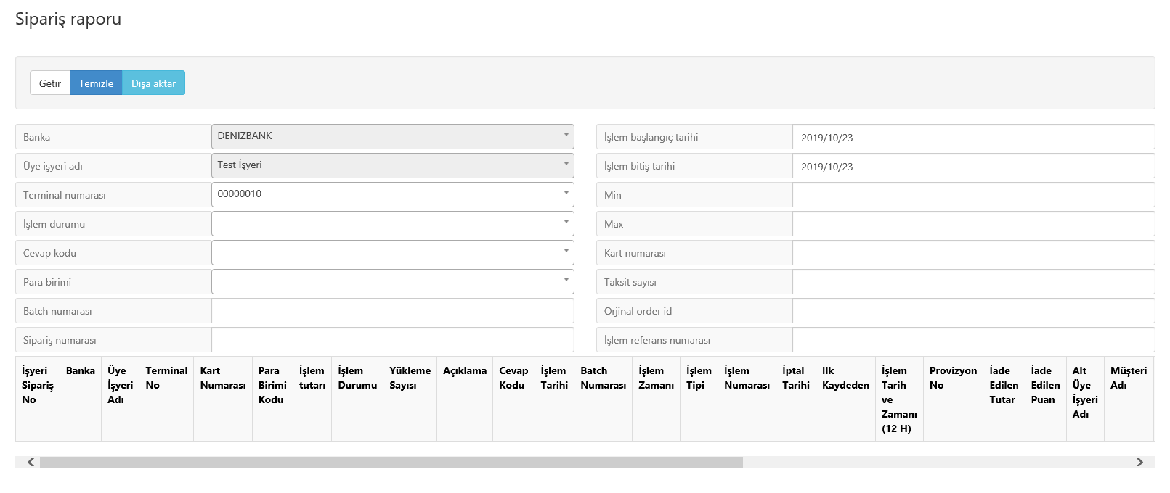

5.3. Batch Query

Through this display reporting can be done by criteria of “Batch Number”, “Batch Status” ve “Date Interval”. By the way of pressing “Transfer-Export” button, it is possible to create enlisted transaction activities in csv, pdf, excel, word, text forms and save them in a storage area indicated in local disk of a computer.

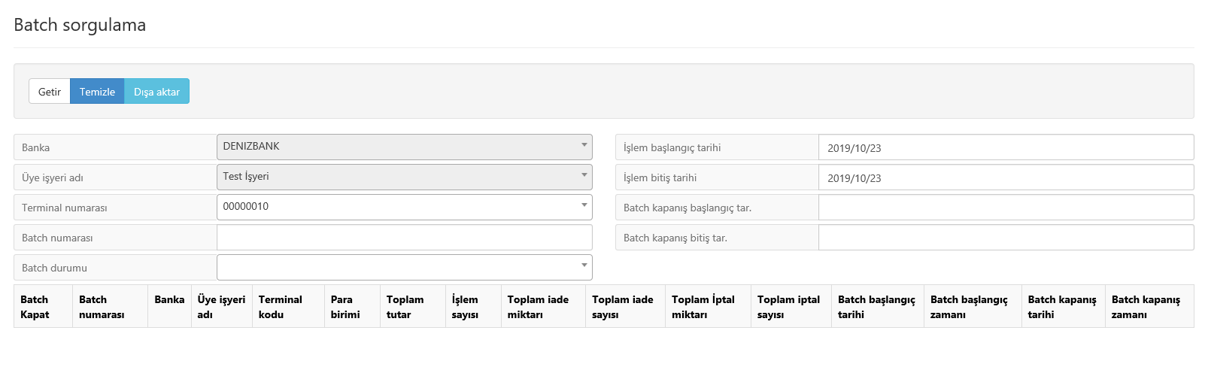

6. Additional Information

Prod environment access details : https://spos.denizbank.com
Shop Code :
User Code :
Password :

Test environment access details : http://sanaltest.denizbank.com
Shop Code :
User Code :
Password :
Note : The user details will be sent via e-mail as well.

VirtualPos Support Service Contact Information :
In case of any problem about VirtualPos service, support service can be taken from following e-mail address and telephone numbers.

e-mail : sanalpos@denizbank.com

sanalpos@intertech.com.tr

Telephone : +90 (212) 370 66 00

+90 (212) 340 32 89

+90 (212) 340 34 98
Out of Office Hours : +90 (212) 340 34 85

Copyright Notice DenizBank Virtual POS® - Inter-VPOS® - Inter-POS® All rights reserved.

Whilst every effort has been made to ensure that the information in this document is accurate, DenizBank does not accept any liability for any errors, omissions, or losses resulting from any party’s actions or avoiding-negligence in taking due actions, either natural or legal. The information in this document may be changed at any time without being obliged to give notice to any party.
Without written permission of DenizBank A.Ş, no part of this document may be distributed, copied and transferred in any form by electronic or mechanical means or by any other means and methods. This document may be changed without any further notice. All brand names and product names mentioned in this document are registered trademarks.

